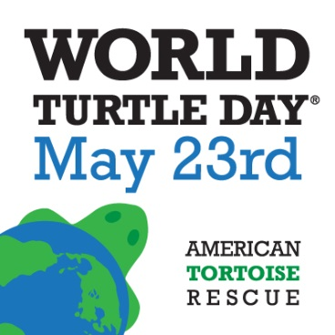
World Turtle Day® International Celebration is May 23
Theme “Turtles Rock!” Says Turtles Are Not Rocks With Legs
Malibu, California -- April 12, 2021 -- American Tortoise Rescue (ATR), a nonprofit organization established in 1990 for the protection of all species of turtles and tortoises, is “shellebrating” its 21st international World Turtle Day® on May 23, 2021. ATR created and launched WorldTurtleDay.org to increase respect for and knowledge about one of the world’s oldest creatures. Now observed around the globe, turtle and tortoise lovers show their appreciation of the special day by taking “shellfies” and “shellebrating” with events and shares on social media. Millions of turtle lovers in the U.S., Canada, Pakistan, Borneo, India, Australia, the UK, Greece and many other countries worldwide now observe the day.

This year’s theme “Turtles Rock!” encourages a worldwide audience to see turtles as more than just rocks with legs. The sentient beings are amazing creatures that outlasted dinosaurs and live 25 to 50 years or more. They feel happiness and pain, show a true sense of humor, as well as affection.

Susan Tellem, RN, BSN co-founded the ATR sanctuary with her husband, Marshall Thompson, 31 years ago. Together, they have rescued and rehomed more than 4,000 turtles and tortoises. “Turtles Rock because they have personalities just like dogs and cats,” Tellem says. She added that when they are allowed to live wild in a safe environment at the sanctuary, they search for food, make wonderful photo subjects, do funny things like walking backwards or honking, and most important, have relationships with other turtles.

“People can follow us and join our events live on Facebook and Instagram at World Turtle Day, find tips for fun things to do on www.worldturtleday.org and have the opportunity to score cool turtle items during giveaways. Even though we can’t meet in person,” Tellem says, “We can show our love of these beautiful creatures by enjoying experiences together through social media.”

Some of the highlights to help make World Turtle Day special include:
• Join the party at home or at work. ATR created a World Turtle Day Party Pack that can be accessed for free here http://bit.ly/1YwebJR
• Follow the World Turtle Day page on Facebook and Instagram to join thousands of fans who are posting shellfies, videos and photos in honor of World Turtle Day.
• Follow @WorldTurtleDay on Twitter. Every year, thousands of people help the day trend by tweeting #worldturtleday to spread the good word about turtles.
• Subscribe to our YouTube for the latest turtle and tortoise videos and ideas at www.youtube.com/americantortrescue.

These gentle animals survived 200 million years, yet they are rapidly disappearing as a result of smuggling, habitat destruction, climate change, the cruel pet trade, and live exotic food markets domestically and internationally. About 61% of turtle worldwide are threatened or already extinct. According to experts, turtles are the most threatened of the major groups of vertebrates, more so than birds, mammals and fish. Tellem says this is why education is so important in every country globally so that turtles can be treasured, not eliminated.

“Ideally, all turtles should live in the wild, but realistically this is not always possible. Too many are sold at pet stores, by street vendors or used as prizes at carnivals and other events. Thankfully, there are many more rescues and sanctuaries now, as well as loving homes,” Tellem says, “where turtles can safely live out their long lives.”
Authentic World Turtle Day® shirts, hats and hoodies are available for sale only through American Tortoise Rescue. Inquire at info@tortoise.com.
Media Contact Information: Susan Tellem, RN, BSN; info@tortoise.com
Please tweet these tweets
#Shellebrate and protect turtles and tortoises on #WorldTurtleDay May 23
#shellebrate #worldturtleday May 23
#Free #WorldTurtleDay® Party Pack http://bit.ly/2qdo4El
#WorldTurtleDay® May 23 #TurtlesRock
Note: World Turtle Day® is trademarked – please use registered symbol.

